02 -

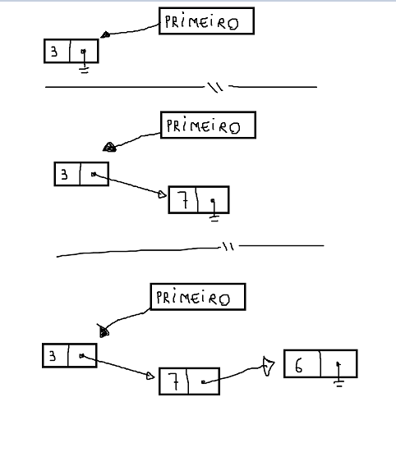

03 –

|  |  |  |
| --- | --- | --- |
| **Valor** | **Atual** | **anterior** |
| 1 | 1 | 1 |
| 5 | 5 | 1 |
| 2 | 2 | 5 |